8. Results:
Theoretical Practical
470
220
1K

Table 3.1: Data for I - V characteristics.
V (volts) | (volts) | (volts) | Iz = VR / R (ma)
0.1
0.3
0.5
0.7
1.0
2.0
3.0
4.0
5.0
6.0
7.0
8.0
9.0
10.0

Table 3.2: Data for Load Regulation
POT R (k) | V220 (mV) | VL (volts) | IL (Amp)= V220/220

Table 3.3: Data for Line Regulation.
V (volts) | V_{L} (volts)
1.0
3.0
6.0
8.0
9.0
10.0
11.0
12.0

9. Questions and Answers:
Q1: Plot characteristics of Zener diode. Determine the Zener breakdown voltage from the plot.
Ans:
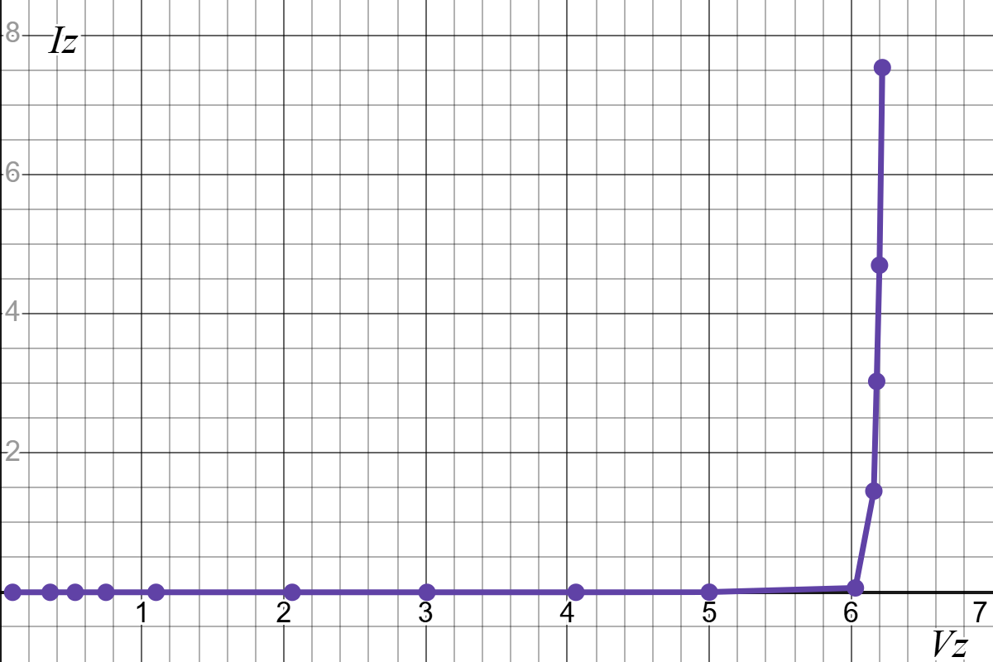

Q2: Plot IL vs VL for the data table 4.2. Scale [ x-axis: 0.1V/DIV, y-axis: any
suitable range]. Find the Load regulation from the graph.
Ans:
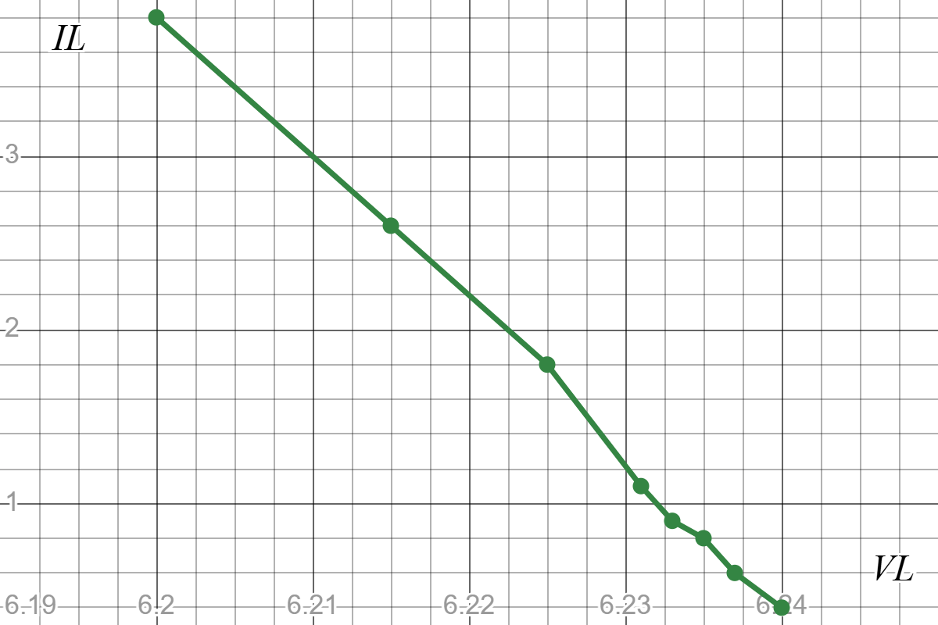

Q3: Plot VL vs V for the data table 4.3. Find the line regulation from graph.
Ans:
